LAB 9

The task is to complete the login flow. It is a simple flow with 3 view-states & an action state:

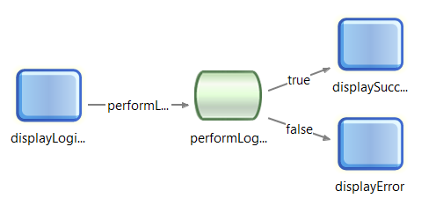

The startup page:

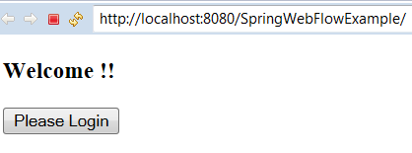

The flow is activated by clicking on the Please Login button.

**Display Login view:**

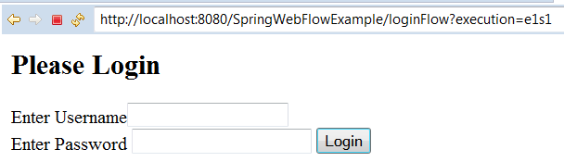

**Success View:**

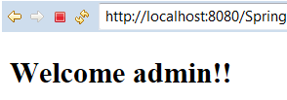

**Failure View:**

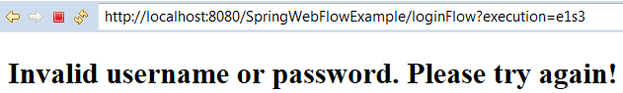

**Project structure:**

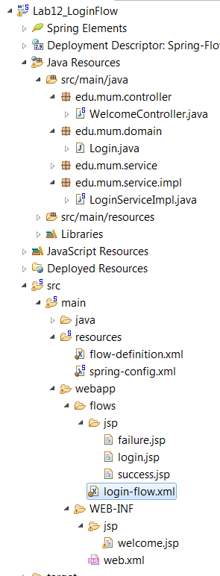

**Tasks:**

1. Complete the flow-registry in the flow-definition.xml file.
2. Link the Please Login button to the flow [login-flow.xml] in the welcome.jsp page.
3. Convert the action-state expression from a call to the LoginServiceImpl to a call a LoginControllerHelper.
4. Complete the transitions in the action-state to go to the success & failure view-states.
5. Implement the success & failure view-states.
6. Username/password = admin.